Benha University, Faculty of Science Entomology Department

Midterm, 2nd Semester, 2016, General Entomology2 (112E)

Time allowed 30 Minutes

- Complete the missing parts in the following figures

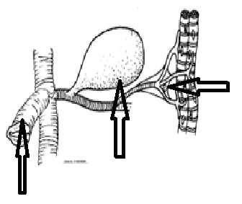

- Discus the following statement: Some insect species are able to reproduce asexually.

- Write on: Diaphragms and sinuses in hemolymph circulation in insects

